CHE 517 Advanced Process Control
Final Exam

Problem #1 (20%)
Figure 1 shows the block diagrams of two dynamic processes.
- Which or the two processes should be controlled by a cascade system in order to improve its closed-loop behavior to changes in disturbance d1? Why?
- Construct the cascade system for the process you selected in part (a) for cascade control. Draw the corresponding block diagram using two proportional controllers.
- Select the gains of the two proportional controllers so that you can have the “best” closed-loop response to changes in load d1 without endangering the stability of the system.

Problem #2 (20%)
(a) Develop a feedforward-feedback control system for a process with the following transfer functions;
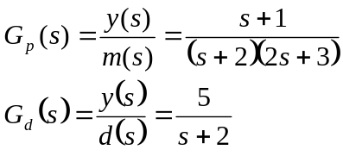
The following specifications are also given: (1) use a PI controller for the feedback loop, and (2) the feedforward system should have both disturbance rejection and set point tracking capabilities.

(b) Show how would tune the feedback PI controller.
(c ) Derive the conditions that must be satisfied in order to have stable closed-loop response. Do these conditions depend on both feedforward and feedback characteristics?

Problem #3 (20%)
Consider the following process with three inputs and three outputs.
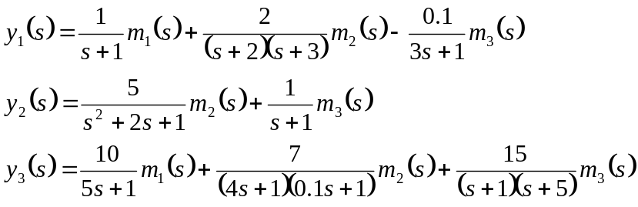
Using Bristol’s relative gain array, select the control loops with minimum steady state interaction.

Problem #4 (20%)
Consider the feedback loop shown in the following figure.
- Derive an expression for the closed-loop response to set point changes.
- Set K_{m}=1 and τ_{m}=0 and find the largest value of gain K_{c} (ultimate gain) that will give stable response.

Problem #5 (20%)
Is the following system (a) reachable? (b) observable?
